
NOTE: This is an official document by Indexademics. Unless otherwise stated, this document may not be accredited to individuals or groups other than the club IDX, nor should this document be distributed, sold, or modified for personal use in any way.
IDX G9 Physics S+ STUDY GUIDE ISSUE 7
By Ziyu Pan and Aiden Zhan

Contents:
- 5.3 Highway Curves, Banked and Unbanked
- 5.6 Newton’s Law of Universal Gravitation
- 5.7 Gravity near the earth surface Geophysical applications
- 5.8 Satellites and “Weightlessness”
- 5.9 Kepler’s Law and Newton’s Synthesis

5.3 Highway Curves, Banked and Unbanked
- Unbanked Curve
- Centripetal Force: The force that keeps a car moving in a circle. It is provided by static friction if there is no other force.
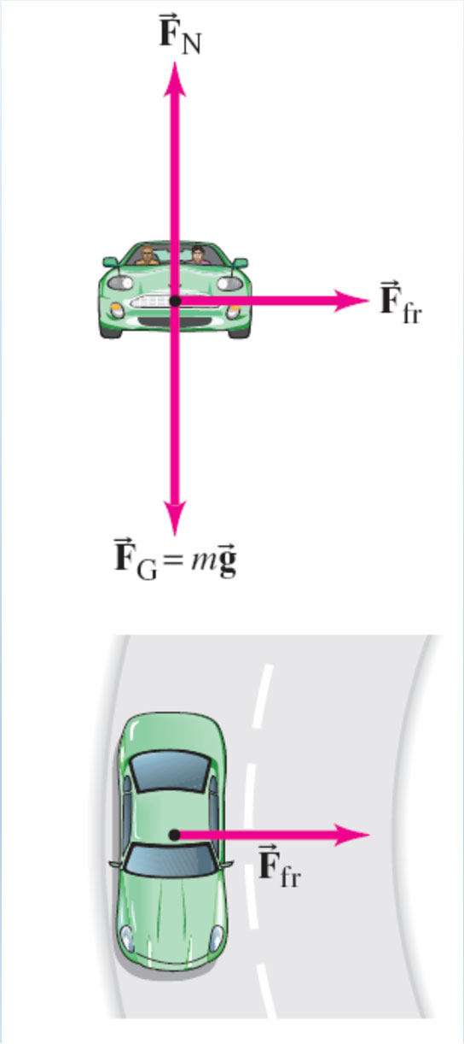
$F_{net}=F_{f}=F_{R}=\frac{mv^{2}}{r}=μ_{s}mg$
- Static Friction: If the friction is not enough, the car will move straight in the direction of the tangent, law of inertia.
- Example:
  - For a car (mass = 1,000 kg) moving at 14 m/s on a flat curve with radius 50 m:
$$μ_{s}mg=\frac{mv^{2}}{r} \\ μ_{s}=\frac{v^{2}}{rg}=0.4 \\ F_{R}=μ_{s}∙F_{N}=3900N$$
- Banked Curve
Free body diagram:
- Banked Curves: Curves that are tilted to help vehicles turn without relying on friction.
- Design Speed (v): A banked curve has a specific speed where friction is not needed.
- Formulas:
  - For unbanked curves: The maximum speed is determined by the friction coefficient:
$$v_{max}=μ_{s}gr$$
  - For banked curves: The speed can be calculated using:
$$v=\sqrt{gr tan(θ)}$$

- When speed is too high or too low:
  - Too fast: Friction increases to help keep the car from sliding outward.
  - Too slow: Friction decreases to prevent the car from sliding inward.
- Example:
- For a car takes a banked curve at less than the ideal speed, friction is needed to keep it from sliding toward the inside of the curve, Calculate the ideal speed to take a 100 m radius curve banked at 15.0º :

$v= \sqrt{grtanθ}= \sqrt{9.8× 100 × tan 15°} = 16.2 m/s$
Check Your Understanding
- What happens if a car takes a turn on an unbanked curve with insufficient friction?
- How does the angle of a banked curve affect the car's required speed for safe turning?

5.6 Newton’s Law of Universal Gravitation
- Statement: Every particle in the universe attracts every other particle with a force proportional to the product of their masses and inversely proportional to the square of the distance between them. This force acts along the line joining the two particles.
- Formula:
$$F_{grav}=\frac{G∙m_{1}∙m_{2}}{r^{2}}$$
Where:
    - $F_{grav}$ is the gravitational force
    - $G$ is the universal gravitational constant ($G=6.67×{10}^{-11} Nm^{2}/{kg}^{2}$)
    - $m_{1}$ and $m_{2}$ are the masses of the two objects
    - $r$ is the distance between the centers of the two objects

Key Concepts:

Mass of one planet doubles: The gravitational force doubles.

Distance doubles: The gravitational force becomes one-fourth as strong.

Cavendish Experiment

Measuring G: In 1798, Henry Cavendish used a torsion balance to measure the gravitational force between two objects, allowing for the calculation of the universal gravitational constant G.
- Important Constants:
- Mass of Earth: 5.972 ×${ 10}^{24}$ kg
- Radius of Earth: $6.38 × {10}^{6} m$
- Mass of Moon: $7.342 × {10}^{22}$ kg
- Distance between Moon and Earth: $3.844 × {10}^{8} m$
- Mass of Sun: $1.989 × {10}^{30} kg$
- Distance between Earth and Sun : 1 AU = $1.496 × {10}^{11} m$
- Speed of light: $3 × {10}^{8} km/s$
- A light year : 9.41 $× {10}^{15} m$ $≈ 30 AU$
- Example:
- Find the gravitational force between the sun and the Earth:
$F_{g}= \frac{GM_{Sun}M_{E}}{r^{2}}$ = $(6.67× {10}^{-11})\frac{(5.972×{10}^{24})(1.989 × {10}^{30})}{{(1.496 × {10}^{11})}^{2}}$ =$3.54×{10}^{22}$N

5.7 Gravity near the earth surface Geophysical applications

Acceleration Due to Gravity

On Earth's Surface:
$$\overline{g}=9.8 m/s^{2}$$
  - Solving for g gives:
$g= G\frac{M_{E}}{r_{E}^{2}}$
  - Far from Earth's Surface: As the distance from Earth's center increases, the gravitational force decreases.
$$a=\overline{g}{ (\frac{r_{E}}{r})}^{2}$$
Where:
    - $a$ = acceleration due to gravity at distance r
    - $r_{E}$ = radius of Earth
    - $r$ = distance from Earth's center

5.8 Satellites and “Weightlessness”
- Key Concepts:
  - Free fall: When an object is falling with only gravity acting on it, without air resistance.
    - Straight-line fall: Free fall directly toward the center of Earth.
    - Projectile fall: When an object is launched at an angle or horizontally, its path curves.
  - Curvature of the Path: If an object moves fast enough, its curved path matches Earth's curvature and it can enter orbit.
  - Satellite Motion: A satellite orbits Earth in a path where the horizontal velocity is balanced by the centripetal force, maintaining orbit.
  - Weightlessness: Occurs when an astronaut in orbit feels "weightless" because both the shuttle and the astronaut are in free fall together. The gravitational force is not zero, but there is no apparent weight due to lack of support force.
- Important Equations:
  - Orbital Speed: $v=\sqrt{\frac{GM}{r}}$​($M$ is the mass of central object)
  - Orbital Period: $T=2π\sqrt{\frac{r^{3}}{GM}}$
- Example:
Assume that a satellite orbits Earth 225km above its surface. Given that
the Earth’s mass is 5.97×${10}^{24}$kg, and the radius of the Earth is 6.38×${10}^{6}$
m, what are the satellite’s orbital speed and period?

$v=\sqrt{\frac{GM}{r}}$ = $\sqrt{\frac{6.67×{10}^{-11}×5.97×{10}^{24}}{6.38×{10}^{6}+2.25×{10}^{5}}}$ = $7.76×{10}^{3}m/s$
$T=2π\sqrt{\frac{r^{3}}{GM}}$ = $\sqrt{\frac{{(6.38×{10}^{6}+2.25×{10}^{5})}^{3}}{6.67×{10}^{-11}×5.97×{10}^{24}}}$ = $5.34×{10}^{3} s$
Check Your Understanding:
- What causes an object to stay in orbit around Earth?
  - Gravitational pull and inertia.
  - The object’s speed and centrifugal force.
  - Only air resistance.
  - Weightlessness.

5.9 Kepler’s Law and Newton’s Synthesis
- Key Concepts:
  - Kepler’s Laws:
- First Law: Planets orbit the Sun in elliptical paths, with the Sun at one focus.
- Second Law: A line drawn from the Sun to a planet sweeps out equal areas in equal time intervals. Planets move faster when closer to the Sun.
- Third Law: The square of the ratio of the periods is equal to the cube of the ratio of their average distance. ${(\frac{T_{A}}{T_{B}})}^{2}={(\frac{r_{A}}{r_{B}})}^{3}$
  - Orbital Relationships: Orbital period and distance depend on the mass of the central object and the radius of the orbit. Kepler’s third law can be derived using Newton’s law.
Check Your Understanding
- Which of the following best explains why astronauts on the International Space Station (ISS) feel weightless?
- There is no gravity acting on the ISS because it is above Earth's atmosphere.
- The ISS is far enough from Earth that gravity is zero.
- The ISS is in constant free fall, accelerating toward Earth at the same rate as the astronauts.
- The ISS uses thrusters to cancel the effects of gravity on the astronauts.

